JAVA SCRIPT TEST
Q1.
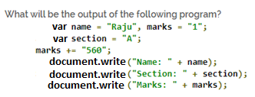
Q2.
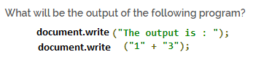
Q3. In a company, worker efficiency is determined on the basis of the time required for a worker to complete a particular job. If the time taken by the worker is between 2 – 3 hours, then the worker is said to be highly efficient. If the time required by the worker is between 3 – 4 hours, then the worker is ordered to improve speed. If the time taken is between 4 – 5 hours, the worker is given training to improve his speed, and if the time taken by the worker is more than 5 hours, then the worker has to leave the company. If the time taken by the worker is input through the keyboard, find the efficiency of the worker.
Q4. A certain grade of steel is graded according to the following conditions:
(i) Hardness must be greater than 50
(ii) Carbon content must be less than 0.7
(iii) Tensile strength must be greater than 5600
The grades are as follows:
Grade is 10 if all three conditions are met
Grade is 9 if conditions (i) and (ii) are met
Grade is 8 if conditions (ii) and (iii) are met
Grade is 7 if conditions (i) and (iii) are met
Grade is 6 if only one condition is met
Grade is 5 if none of the conditions are met
Write a program, which will require the user to give values of hardness, carbon content and tensile strength of the steel under consideration and output the grade of the steel
Q5. Write a program to check the expression is true or false
a=10, b=12, c=0;
expression:1: (a!=6 && b>5)
expression:2 : (a==9 || b<3)
expression:3 : (!(a<10))
expression:4 : (!(a>5 && c))
expression:5 : a==20 && c!==8 ||!c
Q6. Write a program to calculate the area of the circle by giving the value of radius through user on runtime.
Q7. Determine if the number is positive or negative.
Q8. Write a program to find who is younger from Huda, Emaan and Sahar when their ages are input through keyboard
Q9. Generate a calculator using Switch Case and take operator from user.

Q10. Write a program to generate tables of num 3.
Q11. Write a program which tells the prime numbers till 10.

